# White led bricks

1. Print out bricks
2. Cut two wires approx 10 inches long with ¼ inch stripped and exposed wire on one side
3. Put white led into the brick with the cathode (long lead) on top
   1. Make sure to have the “bubble” of the LED protruding from the side of the lego with the small vertical slit, not the hole. The hole is used for hot glue and anchoring the LED in place.
4. Hot glue the LED in place, filling the divot in the brick
5. Bend the leads of the led in prep for wire soldering

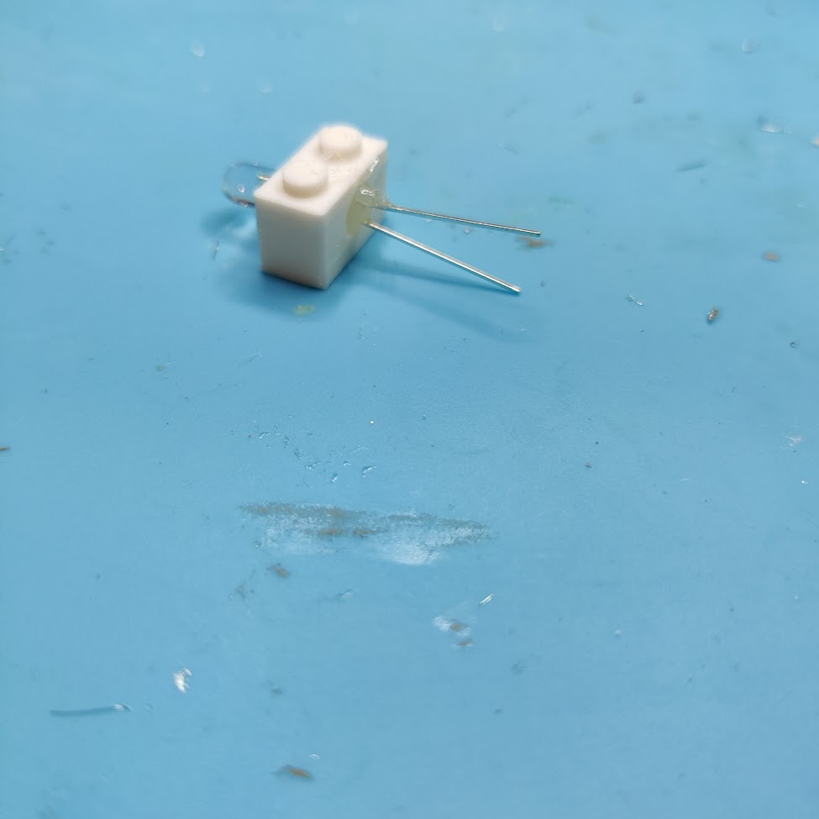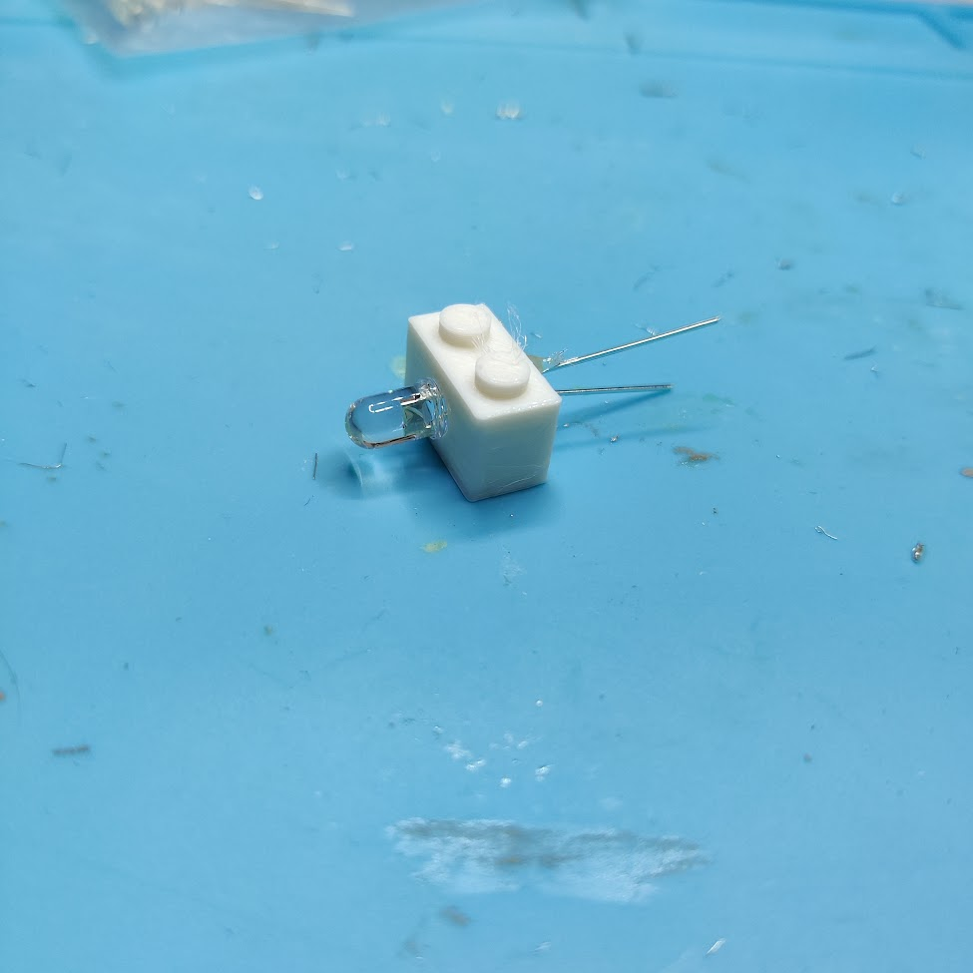

1. Solder each wire to the LED
   1. I used red for cathode and black for anode
2. Cut approx. quarter-inch of 1/8th inch shrink wrap to fit the sensor
3. Push shrink wrap up the wires so they touch the brick
4. Shrink the wrap with a heat gun
5. Cut ¼ inch of ⅜ inch shrink wrap, and fit the wrap over all wires of led. This protects the wires from bending at an awkward angle.
6. Treat with heat gun to shrink.

# Teal Sensor Bricks

1. Print out bricks
2. Cut three wires approximately 10 inches long with ¼ inch stripped and exposed wire on one side
3. Put photoresistor into the brick on the side with the small vertical slit, not the hole. The hole is used for hot glue.
4. Push leads of the photoresistor to opposite sides of hot glue hole, fill with hot glue
5. Bend leads of the photoresistor to prep for soldering resistor and wire.

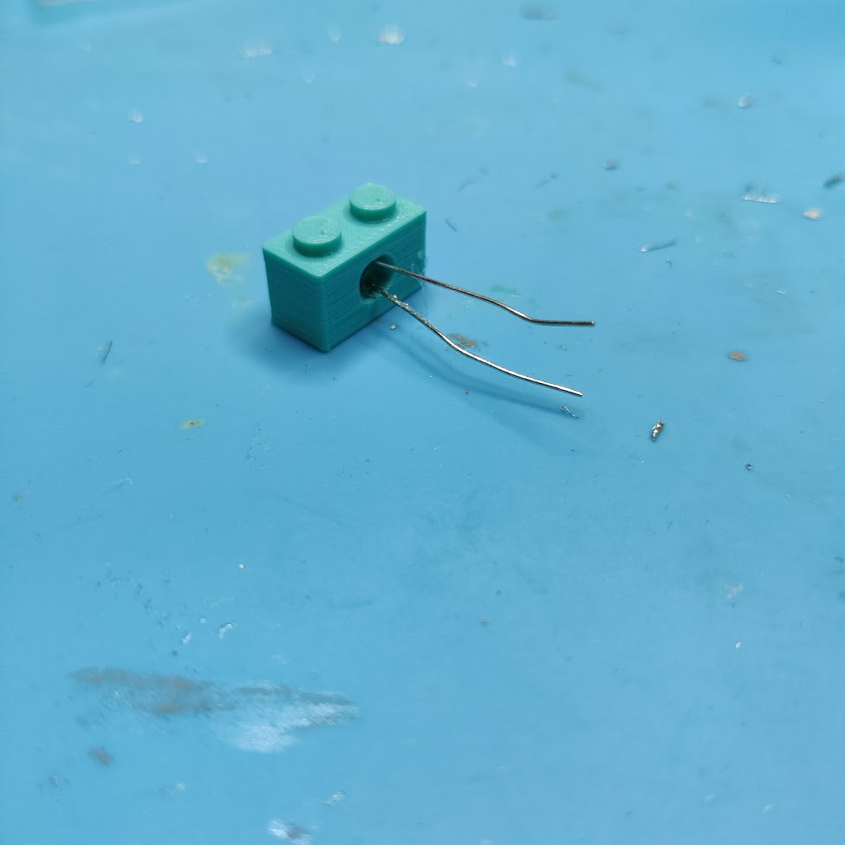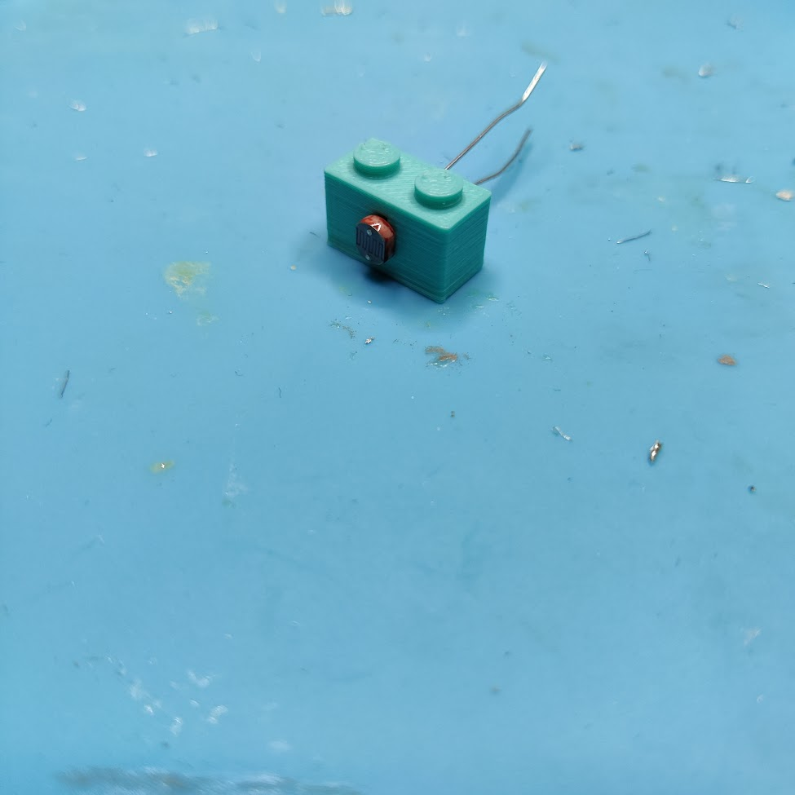

1. The bottom lead will act as ground to the voltage divider, so solder that one first. I used blue to represent the sensor ground.
2. The top lead will need the 10k ohm resistor and a wire to measure the divided voltage soldered to it. Bend and cut both before hooking them all together and soldering the three-wire/component joint. Yellow wire was used for the signal wire for the voltage divider in the sensor
3. Finally, solder the +3.3v wire to the other end of the resistor. White was used for the 3.3v wire.
4. Prepare shrink wrap:
   1. 1/8th inch long of 1/8th inch diameter
   2. 1/4th inch long of 1/8th inch diameter
   3. 1/2th inch long of 4mm inch diameter
   4. 1/2th inch long of 3/8th inch diameter
5. Use shrink wrap a) to cover the joint between the white wire and resistor
6. Use shrink wrap b) to cover the joint between photoresistor and blue wire
7. Use shrink wrap c) to cover the joint between the photoresistor, resistor, and the signal (yellow) wire. Make sure to feed the shrink wrap through both the white and yellow wire.
8. Once a-c has been shrunk, combine all three wires and two components together with shrink wrap d).

# Neopixel Assembly

1. Cut and strip three wires to ten inches long with ¼ inch exposed wire on one side.
2. Place the neopixel strip on a heat-proof surface with the solder pads facing up.
3. Tape the neopixel strip down with duct tape/electrical tape’
4. Apply solder paste to the solder pads
5. Align wires with solder pads, and apply solder. Try to minimize exposed wire hanging out of the board, as it would be a point of weakness.

# Full Board Assembly

1. For each wired brick, pull the wires and cut any excess length to ensure all wires are the same length. Strip each wire so they have the same length of exposed wire (approx. ¼ inch)
2. Use helping hands to arrange the neopixel board stationary with extra hands to help with wires.
3. Begin with the neopixel brick, soldering it into the RPi Pico board following the wiring guide spreadsheet. Make sure wires are going into the side of the Pico board with the processor. Having the processor facing up allows for a clean connection on the printed lego-adaptor. Additionally, it is nice for the students to see the components of the chip easily.
4. Once neopixel is assembled, it is highly recommended to test the RPi Pico board following the testing document to ensure that the board works before continuing.
5. If the board is working properly, continue to solder the two sensor bricks and fan module in accordance to the wiring spreadsheet.
6. Proceed to full-board testing at the bottom of the testing document.